**Brooklyn torah gazette**

**For parshas re’eh 5780**

Volume 4, Issue 45 (Whole # 197) 25 Menachem Av 5780/ August 15, 2020

**Printed L’illuy nishmas Nechama bas R’ Noach, a”h**

**Historic Beirut Synagogue Destroyed 'Beyond Repair'**

**By Arutz Sheva Staff**

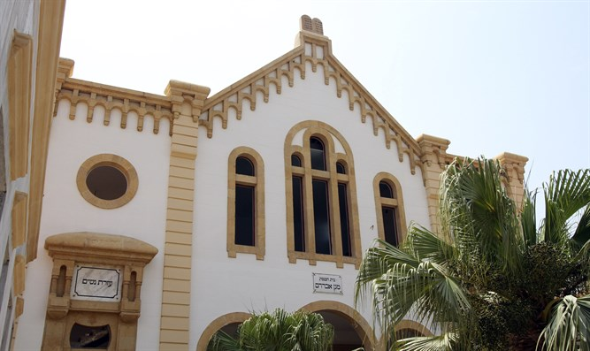

**Maghen Abraham synagogue in Beirut (photo by Reuters)**

In Lebanon, new updates continue to roll in regarding the heavy damage caused by the [explosion in the port of Beirut last week](http://www.israelnationalnews.com/News/News.aspx/284827) [on Tuesday, August 4, 2020). According to local reports, the only remaining synagogue in the country,

Maghen Abraham, was badly damaged and it is now doubtful whether it can be restored.

The synagogue has been inactive for years, but Lebanese authorities have preserved it as a historic site. It's located in the Wadi Abu Jamil district in downtown Beirut, where the city's Jewish quarter used to stand, a few kilometers from the port of Beirut.

Built in 1925, it is the oldest Jewish house of worship in the Lebanese capital, and was named after the son of Abraham Sassoon, Moise Abraham Sassoon of Calcutta. It was built on land donated by Raphael Levi Stambouli, and designed by the architect Bindo Manham.

Due to difficulties in financing the project, the head of the Jewish community of Lebanon, Yosef Farhi, ended up assisting with the purchase of religious items as well as the inside structure of the building. A number of social institutions situated their offices in the synagogue's courtyard.

Lebanon's Jewish community once numbered up to 22,000, when the country served as a refuge for those who fled the Spanish Inquisition. But Jews fled the country during the 20th century, until finally even the Maghen Abraham Synagogue closed its doors in the mid-1970s.



***Another view of the reportedly destroyed Maghen Abraham synagogue in Beirut.***

After 1971, only two Jews remained in the Wadi Abu Jamil area of Beirut, just 60 in the entire country, with the once-prominent community virtually ceasing

to exist. In 1976, a year after the civil war began, the synagogue closed, and the Torah scrolls were taken to Geneva, where they were given to renowned Jewish-Lebanese banker Edmond Safra. There they were placed in Safra's bank vault, where they were stored until they were eventually relocated to Sephardic synagogues in Israel.

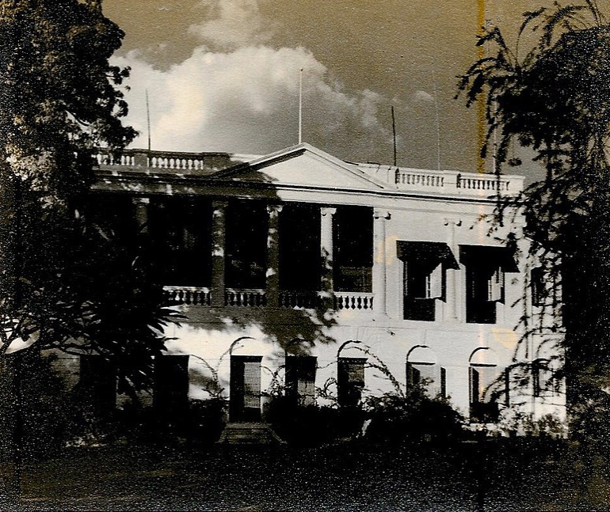

**The home of Moise Abraham Sassoon in Calcutta. One of the grand residences of the Baghdadi Jewish merchant elite in the early 20th century for whom the Beirut landmark synagogue was named after.**

At the end of the civil war, Lebanese Prime Minister Rafic Hariri decided to rehabilitate the synagogue and surround it with a garden. The plan did not materialize, but the synagogue is [or was] considered a historical site.

*Reprinted from the August 10, 2020 email of Arutz Sheva.*

**Rabbi Berel Wein**

**On Parshat Re’eh**

**By Rabbi Berel Wein**

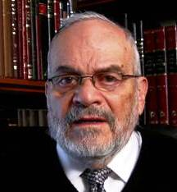

To Moshe, life choices are clear and self-evident. He tells the Jewish people to merely look, and they will see the difference between life and death, good and evil, eternity and time-burdened irrelevance. He implores the Jewish people to use their common sense, to pay attention to the experiences over the past 40 years in the desert, and their story. Then, they will be able to clearly see their choices in life, and what basic decisions they must make regarding what should be visible and obvious to them.

Yet, we know that even when people are aware of the consequences of their behavior, when, so to speak, they actually do see the differences and choices that lie before them, they will often choose to sin and take the wrong turn in life. People know that all addictive drugs and immoral behavior inevitably lead to personal disaster. The evidence for this is so abundant that all of us know cases and people that somehow willingly and even voluntarily choose this path of self-destruction. None of this holds people back from themselves.

**The Man Who Was**

**Becoming an Alcoholic**

The story is told about a man who was becoming an alcoholic, who was taken by his children to visit skid row where the victims of alcoholism reside on the street in their drunken stupor. One of the drunks was wallowing in the gutter amidst the filth that permeated the area. His children – those of the potential alcoholic – said to him: "Father don't you see where excessive drinking will lead you?"

However, the man went over to the drunk in the gutter and whispered to him: "Where did you get such good and powerful whiskey?” We always see what we want to see. What is perfectly obvious to the sane and rational mind, is not seen by one captured by the evil instinct, affected by social pressure, and suffering from a lack of self-discipline

**You Cannot Make a Person**

**Drink from the Fountain**

All parents and educators know you may lead someone to a fountain of fresh water, but you cannot make that person drink from it, unless the person wishes to do so. It is hard to convince people to see what they do not want to see, and to believe what they do not wish to believe. All the exhortations of the prophets of Israel were of little avail in the times of the first Temple, simply because the people refused to see the obvious consequences of idol worship, and the abandonment of Torah and its teachings.

The only hope for parents and educators is to improve the eyesight, so to speak, of their children and students, so that those individuals themselves will be able to perceive the clear difference between life and death, right and wrong. This is a slow and painful process, but with persistence it can be successful and lifesaving. Good eyesight requires tenacity of focus as well as excellent peripheral vision. Jewish tradition and Torah values within both the family and society help provide the good vision which enables productive choices, that will lead to eternal life and goodness.

*Reprinted from this week’s website of Rabbiwein.com*

**Parshas Re’eh**

**Consumerism and the Overspent Generation**

By Rabbi Bentzion Shafier

Founder of TheSmuz.com

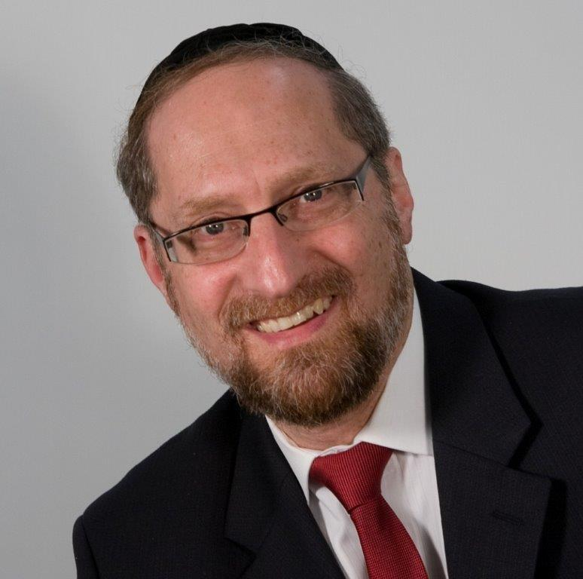

“*When HASHEM your G-d will broaden your boundary as He spoke to you, and you say, “I will eat meat,” for you will have a desire to eat meat, to your heart’s entire desire you may eat meat.*” – Devarim 12:20

For forty years in the midbar the Jewish people ate mon. Guided by Moshe Rabbeinu, engaged in constant Torah study with every physical need taken care of, the Klal Yisrael lived on a lofty spiritual plane. Now that they were being ushered into a different era – entering Eretz Yisroel where they would begin living in a natural manner – they were given many directives to retain their status as an exalted nation.

One of the points that Moshe Rabbeinu made to the Klal Yisrael is that when they settled the land and followed the Torah, they would find success in their endeavors, and HASHEM would expand their borders. When this would occur, they would desire meat. And they would be allowed to eat it anywhere they wished.

Rashi is bothered by the relationship between the expanding of borders and the “desire to eat meat.” It almost implies that the expansion of borders brings on the desire. Rashi explains that the Torah is teaching us a principle in derech eretz. A person should only desire meat when he can afford it. When HASHEM expands our borders and we enjoy financial success, then it is appropriate to desire meat – not before.

This Rashi seems difficult to understand. What is wrong with desiring meat? The Torah might tell me that if I can’t afford meat, I shouldn’t eat it. If it is beyond my means and purchasing it would create an undue expense, I shouldn’t buy any. But what is wrong with just desiring it?

**Pleasures and Lusts**

The answer to this can be best understood with a moshol. Imagine that you find yourself shipwrecked on a desert island. You haven’t eaten in three days, and you are driven by one burning desire – food. As you hobble along the island, you notice a brown paper bag under a palm tree. You open it up to find a dry peanut butter sandwich that has sat out in the sun for three months. You gulp down that sandwich with more gusto than anything that you have ever eaten in your life.

Here is the question: how much pleasure did you derive from eating that sandwich? There is no question that you had a powerful urge, a very real desire, but how much enjoyment did you receive from that activity? The answer is not much. It certainly relieved your hunger, and in that sense brought a release from pain, but it would be hard to imagine that for the rest of your life you would be reminiscing back to the sensation of the bitter, spoiled peanut butter and dry, cracked bread as it scratched your throat when you swallowed it.

This is a good example of the distinction between pleasure and lust. You ate that sandwich with great desire – a lot of passion – but you didn’t derive much pleasure from that activity. Lust is the pull to engage in a given activity. Pleasure is the amount of enjoyment you receive from it. As unusual as it may sound, most people fail to make a distinction between pleasures and passions.

**HASHEM Wants Us to Be Happy**

This seems to be the answer to the Rashi. While it is true that life is a battle, and exerting self-control is the primary vehicle of growth, HASHEM created us to be happy. If you bring new desires into your world, desires that you can’t possibly fulfill, you are destined to be miserable. You will be constantly wanting, constantly hungry. Your life will become the opposite of a pleasurable existence.

The Torah is teaching us that our desires are things that we can and need to control. If you have the capacity to meet the desire to eat meat, there is nothing wrong with allowing those desires to surface. HASHEM created many pleasures for man to enjoy, and you should use those pleasures to better serve Him. But if you don’t have the means to fulfill those hungers and you allow them to be present, then you will be living a very uncomfortable existence, constantly hungering for something that can’t be met.

When HASHEM grants you abundance and you can afford luxuries, then you will desire meat – but not before. The Torah is educating us into a higher form of living. When you enjoy the pleasures and control your desires, you use this world for its intended purpose, thereby living b’ shleimus – complete, not lacking.

**Consumerism - a national culture of competitive acquisitions**

This concept is very applicable as we are the Chosen Nation – expected to be above the rest of the nations. Unfortunately, that sense of living at a higher standard can become perverted into materialism, where the expectation is that for people like “us,” nothing less than the best will do.

And so our weddings, our wardrobes, our homes, and our cars have to be the best. The way our children dress and the types of toys that they expect are nothing short of top-notch. And we find ourselves with an ever-increasing cost of living. When barely surviving in our communities means that we are expected to earn **three** to **four** times the national median household income, something is wrong with our lifestyle.

We live in times of mass prosperity where the average person is rich, but to enjoy that great bracha, we must maintain control. Everything in this world was created for man’s use – but it must be used properly, in balance, in the right time, and in the right measure. When man does that, he enjoys his short stay on this planet and accomplishes his purpose in Creation.

*Reprinted from this week’s website on TheShmuz.com This is an excerpt from the*[*Shmuz on the Parsha book*](https://theshmuz.com/product/shmuz-on-the-parsha-book/)*.*

**The Importance of a Jew’s .G-dly Service Being Performed with Open Eyes**

**From the Talks of the Lubavitcher Rebbe**

**Rabbi Menachem Mendel Schneerson, Zt”l**

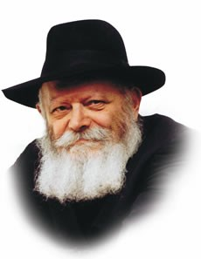

This Shabbat is the first day of Rosh Chodesh Elul, a particularly auspicious month that possesses a unique dimension. For during this month, G-d is especially close to us and we are granted an extraordinary capacity for teshuva -- "return."

As every Torah portion has particular relevance for the time of year in which it is read, let us examine the connection between the month of Elul and the Torah portion which we read this Shabbat.

Our portion begins with the words, "See! This day I give to you a blessing and a curse." Every word in this verse contains an allusion to the special nature of the service of the month of Elul, and the Divine assistance we are given to fulfill it.

"See!": The first thing a Jew must do is to open his eyes. Our sense of sight affords a much more definitive verification of facts than does our sense of hearing; when a person sees something with his own eyes he cannot be dissuaded. A Jew's G-dly service must be performed with this same level of absolute confidence and conviction.

But how are we, mere human beings living in a physical world, supposed to attain this level? G-d provides the answer in the next word of the verse:

|  |  |
| --- | --- |
| **"I" ("Anochi")** | The word "Anochi" relates to the Essence of G-d, an aspect of G-dliness that is higher than Names. The reason we are able to achieve these lofty spiritual heights is because the power to do so is derived from this highest of Sources. |
| The Torah continues: | |
| **"Give"** | G-d gives us this Divine assistance according to the principle of "He who gives, gives generously"; His gifts are bestowed willingly and in great abundance. |
| **"To you" ("Lifneichem")** | This word is related to the Hebrew word "penimiyut," meaning "inside" and "within." The special boost we receive from G-d during Elul is not superficial, but involves the sum and substance of the Jew and enables him to connect with G-d on the deepest level. |
| **"This day"** | Lest anyone think that this Divine assistance is granted only once, the Torah tells us that G-d's help is ongoing, enabling us to serve G-d with renewed strength every day of the month. |
| And how are we to properly utilize this added dimension in our service? | |
| **"A blessing and a curse"** | This refers to the observance of the Torah's positive commandments and the avoidance of its prohibitions. |

Directing our added capacity for teshuva in these two directions will result in a good and sweet new year and a favorable inscription in the Book of Life.

*Reprinted from the Parshat Re’eh 5755 edition of the Lubavitch Youth Organization. Adapted from Likutei Sichot of the Rebbe, Vol. 2.*

**The Prisoner with a Smile**

**By Rabbi Moshe Meir Weiss**



The chaplain in Albany walked into the jail and was surprised to see a prisoner in a tiny little cell, lying on a narrow cot, reading and smiling. It looked so incongruous to see a man in a little cell with an open toilet smiling as if he doesn’t have a care in the world.

The chaplain approached the prisoner and asked him, “What are you smiling about?”

Through the bars, the prisoner replied, “Why shouldn’t I be smiling? I’m living the American Dream. I have everything I could dream of. I am served three meals a day. There’s a well-stocked gym. I’m going to college here. I would never have been able to afford these things. All my needs are taken care of.”

The prisoner was answering in utmost sincerity. He is sitting behind bars in a tiny little room with an open toilet and he felt like he was living the American Dream.



It is an epiphany. Here we are living in galus; we are in jail and yet, we feel like we’re living the American dream. We are in jail; we are away from our land and so far from the glory that we had. We don’t have the Beis Hamikdosh. We can’t do the mitzvos of aliyah l’regel, karbanos, and hilchos tumah v’tahra. We are missing the joy of doing so many mitzvos.

We have to realize all the things that we’re missing. Our life is a shadow of our glorious past. All the radiating kedusha that was once with us is gone, yet we feel like we’re living the dream.

*Reprinted**from the Parshat Eikev 5780 email of Oneg Shabbos (United Kingdom) Originally published in the TorahAnytime.com Newsletter.*

**Opinion**

**The Beirut Blast Wasn't Supposed to take Place in Beirut**

**By Rabbi Lazer Brody**

**Hezbollah missiles tipped with ammonium nitrate were supposed to rain on Haifa.**

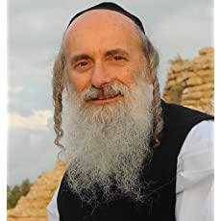

**Rabbi Lazer Brody**

Because of the preoccupation with the Coronavirus, the blast in Beirut on Tuesday, August 4th got much less attention than it deserved. Sure, the world looked at the explosion in superficial 21st Century style but failed to understand the ramifications of the blast, which are far more important to Israel and the Jewish People than Coronavirus.

While Coronavirus is a pandemic, the Beirut blast wasn't planned to be in Beirut. It was planned to be a Hiroshima holocaust to level the city of Haifa, all of the Haifa Bay area and kill a million Jews, Heaven forbid. Hashem prevented that just as King David said he would.

**A Lesson from King David**

King David said in Psalm 7:16 that our enemy digs a pit but he himself falls into it. That's exactly what Nasrallah and Hezbollah did.

Ler me emphasize that the Lebanese people are not our enemy. Nasrallahh and Hezbollahh are. They stored tons of highly volatile ammonium nitrate illegally in Beirut's Port, despite Nasrallah's denials. The corrupt Lebanese government, which Hezbollah controls by force, blackmail and bribes, knew all about it but didn't do anything.

Other sectors of Lebanon's population, such as the Christians, the Druze and many of the Sunni Moslems, suffer from Hezbollah tyranny and from their emasculated government's lack of protection. The proof is that Hezbollah cared not at all about the safety threat to the Beirut populace.

**What the Liberal Western**

**Media Doesn’t Tell You**

However, what the liberal Western media doesn't tell you is that the ammonium nitrate was destined to become the supercharger of Hezbollah's missile warheads – tens of thousands of them – which turn conventional rockets into quasi nuclear threats as we saw in the mushroom vapor cloud that went up from the explosion in Beirut Port – it looked just like a mini Hiroshima.



**Iranian missiles (illustrative) photo by Reuters**

Here's a little history that the progressive media won't tell you either. Hezbollah became world specialists in developing explosive devices and weapons enhancers through the use of ammonium nitrate. Ammonium nitrate was the explosive material used in the roadside bombs that wounded and killed so many Israeli soldiers between the First and Second Lebanon Wars.

**What Hezbollah was Doing**

Hezbollah exported this sinister know-how to their Afghani counterparts, the Taliban, by way of Iran. According to intel sources, Iran’s Revolutionary Guards (IRG) have been active amongst Taliban terrorists opposing the Afghan government. In fact, the same Iranian IRG military advisors that work with Hezbollah have also worked as advisors to the Taliban.

Now hear this, America – the same roadside ammonium-nitrate based bombs that wounded and killed so many Israeli soldiers are the culprits that maimed and killed so many American soldiers in Afghanistan.

**Putting the Puzzle Together**

When you put the puzzle together, it all connects to Iran.

This massive 2,750 tons of ammonium nitrate, which is 6 million pounds, had been sitting in Hangar 12 of the Port of Beirut, stockpiled by Hezbollah as the secret weapon to implement another Holocaust that Nasrallah and Khomeini had planned for the Jewish People.

**Promising a Nuclear Explosion**

**Against Israel in the Near Future**

In 2016, with a nasty smirk on his face, Nasrallah promised that a "nuclear explosion" just might detonate in Israel in the near future. Ever since, he and the IRG have been promising that Israel's demise is near. While the blast on Tuesday was "accidental", the damage would have been mega-times greater if but a few kilograms of ammonium nitrate were placed at the tips of 150,000 Hezbollah warheads fired with deadly precision all over Israel, Such a supercharger on a warhead makes it tens of times more devastating, depending on the rocket and its payload capacity.

**Israel Knew About the Stockpile**

Israel knew all about the stockpile. The Mossad even tipped off Britain's MI5 recently about 3 tons of the deadly material the Hezbollah stockpiled in the UK, where they were planning a hit similar to their devastating terror attack in Burgas, Bulgaria in July of 2012, when a Hezbollah suicide bomber blew up a bus carrying 42 Israeli tourists. The same was being planned for Golder's Green or Stamford Hill.

Israel cares more about Beirut's citizens than Hezbollah and Iran do - much more.

Contrary to the attempts to pin the blame on Israel, it is easy to prove that Israel had nothing to do with the blast. Hezbollah stockpiled the ammonium nitrate in warehouses that held shipments of Iranian missiles that Hezbollah was also stockpiling.

**Israel Reacts to Hezbollah Threats**

But Israel goes deep inside Syria and Shiite-controlled portions of Iraq to prevent weapons transfers to Hezbollah in Lebanon by ground routes. Israel's Navy also monitors Beirut Port to prevent weapons shipments by sea. In fact, as soon as Israel discovers missile shipments and stockpiles intended for Hezbollah – no matter where they are, in Syria, in Lebanon or in Iraq – Israel attacks and blows them up. There is, however, one exception – the Port of Beirut.

Israel could have easily blown up the weapons stockpiles in the Port of Beirut, but refrained from doing so, despite the terrible threat to its citizens, because Israel knew that the stockpiles stored next to them would also blow up, causing devastation to a civilian population.

**Caring About Preventing**

**Damage to the People of Beirut**

Israel cared about preventing damage to the people of Beirut whereas Nasrallah, Hezbollah, Iran and Khomeini could not have cared less. The arch-terrorist criminal Nasrallah connived that if he stockpiled his weapons where the ammonium nitrate was, they'd be safe from Israel. He was right; he knows that Israel risks its own soldiers to avoid damage to civilian populations of enemy countries. The reason Israel doesn't destroy all of Hezbollah's weapons depots in Beirut Port and in South Lebanon is because they're all in the midst of the civilian population, not just in warehouses but in mosques and hospitals.

**Nasrallah Forgot to Take into**

**Account G-d’s Guiding Hand**

But Nasrallah was wrong about something else – he didn't take G-d's Hand guiding historical events into account. No matter what the human or natural cause of the ignition is found to be, the timing and placement of the event that destroyed Hezbollah's doomsday weapon of ammonium nitrate and ignited the fire in Beirut Port is the result of the Hand of G-d. It is no less than a miracle. Even more telling, while less than 160 people were killed in the blast, which is sad enough, actually the number of fatalities should have been a hundred times greater.

This article is not conventional news, but faith-based news. The purpose is not to present the news, to discuss politics or to analyze military strategy and scenarios. The purpose is to show that when and where the blast occurred means that Hashem is acting for us without our knowledge.

**The Message of Psalm 117**

In Psalm 117, King David calls upon all nations, including our enemies, to praise Hashem, because His mercy on the Jewish People is so great. This really sounds weird at face value: why should Hamas, Hezbollah and Iran praise Hashem for His mercy on the Jews, when their hate for us knows no bounds? The answer is simple – only they know what they have been planning for us and only they know the extent to which Hashem has spoiled their plans.

The least we can do – every Jew or peace-loving human whoever you are and wherever you are – is to thank Hashem, from morning until night. We can never take for granted every new day when the sun shines on is. Thank You, Hashem. G-d bless and warmest regards from the Land of Israel.

**The Biography of Rabbi Lazer Brody**

Rabbi Lazer Brody was born in Washington, D.C and is a graduate of the U. of Maryland in agriculture. He moved to Israel in 1970 and joined the IDF, where he spent 19 years in regular and reserve combat service before becoming a military chaplain until his discharge after 29 years of service.

He was ordained as a rabbi by Rabbi Noach Weinberg of Aish HaTora in Jerusalem and others. He is a sought-after inspirational and motivational speaker to audiences of all backgrounds, both in Israel and abroad, as well as a renowned spiritual guide and life coach and certified personal fitness trainer, health coach and holistic nutritionist.

Reprinted from the August 9, 2020 email of Arutz Sheva